**User Guide for**

**J.A.W.S. Procurement Software**

**Version 1.0.0 - 11 November 2022**

**J.A.W.S. Procurement LTD ||** [**inquiry.jaws@support.ca**](mailto:support.jaws@inquiry.ca) **||+1(800)-900-3001|| www.jawsltd.ca**

**Table of contents**

[**1.**](https://docs.google.com/document/d/1zSVJa6TYadvH8PKt8u7CK32bYSWZ2lhucp-CRYvR9Dk/edit#heading=h.rf92mwf2og1v) **General** [**1**](https://docs.google.com/document/d/1zSVJa6TYadvH8PKt8u7CK32bYSWZ2lhucp-CRYvR9Dk/edit#heading=h.rf92mwf2og1v)

[1.1.](https://docs.google.com/document/d/1zSVJa6TYadvH8PKt8u7CK32bYSWZ2lhucp-CRYvR9Dk/edit#heading=h.r0gle6rww91t) Introduction and Purpose 1

[1.2.](https://docs.google.com/document/d/1zSVJa6TYadvH8PKt8u7CK32bYSWZ2lhucp-CRYvR9Dk/edit#heading=h.b81h14tr86kc) Project References 1

[1.3.](https://docs.google.com/document/d/1zSVJa6TYadvH8PKt8u7CK32bYSWZ2lhucp-CRYvR9Dk/edit#heading=h.2z3u3fgn9sn5) Glossary 1

[**2.**](https://docs.google.com/document/d/1zSVJa6TYadvH8PKt8u7CK32bYSWZ2lhucp-CRYvR9Dk/edit#heading=h.1zl9pgjxfi7x) **System Overview** [**2**](https://docs.google.com/document/d/1zSVJa6TYadvH8PKt8u7CK32bYSWZ2lhucp-CRYvR9Dk/edit#heading=h.1zl9pgjxfi7x)

[2.1. S](https://docs.google.com/document/d/1zSVJa6TYadvH8PKt8u7CK32bYSWZ2lhucp-CRYvR9Dk/edit#heading=h.b5of7wcpcfxi)ystem Application 2

[2.2.](https://docs.google.com/document/d/1zSVJa6TYadvH8PKt8u7CK32bYSWZ2lhucp-CRYvR9Dk/edit#heading=h.hqepaev8mrl1) System Organization 2

2.3. Software Inventory

2.4. Information Inventory

2.4.1. Resource Inventory

1. **General**

1.1. Introduction and Purpose

The purpose of this manual is to assist users in getting acquainted with the J.A.W.S. Procurement system. Otherwise put, it serves to provide instructions and guidelines for the usage of this software.

1.2. Project References

Other pertinent documents include the “Installation Guide for J.A.W.S. Procurement Software”.

[**2.**](https://docs.google.com/document/d/1zSVJa6TYadvH8PKt8u7CK32bYSWZ2lhucp-CRYvR9Dk/edit#heading=h.1zl9pgjxfi7x) **System Overview**

[2.1. S](https://docs.google.com/document/d/1zSVJa6TYadvH8PKt8u7CK32bYSWZ2lhucp-CRYvR9Dk/edit#heading=h.b5of7wcpcfxi)ystem Application

The application J.A.W.S. Procurement Software is designed to automate material acquisition of all types of businesses. It serves as a middle ground between suppliers and businesses. The system allows end users to request item purchase which results in automatically requesting quotations from suppliers of these items.In the case that the lowest quotation is below 5000$, the system will initiate the purchase. On the other hand, if the lowest quotation is above 5000$, the system will require at least 2 quotations before submitting the request to the user’s supervisor for approval. If approved, the system will commence the purchase, and if not, the end user will be informed and the procurement request will close.

[2.2.](https://docs.google.com/document/d/1zSVJa6TYadvH8PKt8u7CK32bYSWZ2lhucp-CRYvR9Dk/edit#heading=h.hqepaev8mrl1) System Organization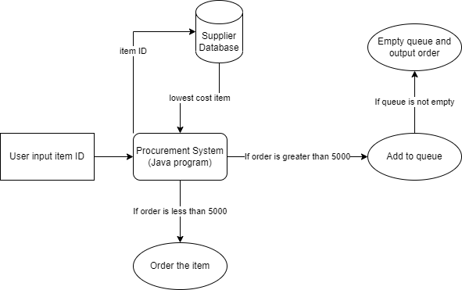

*Figure 1: Logic Diagram*